

***INSTITUTE OF INFORMATION TECHNOLOGY***

***JAHANGIRNAGAR UNIVERSITY***

**Number of Assignment :** 02

**Submission Date :** 10/10/2020

**Course Tittle :** Data & Telecommunications

**Course Code :** ICT - 2109

**Submitted To Submitted By**

Nusrat Zerin Zenia MD. Shakil Hossain

Lecturer Roll – 2023

IIT – JU 2nd year 1st Semester

IIT – JU

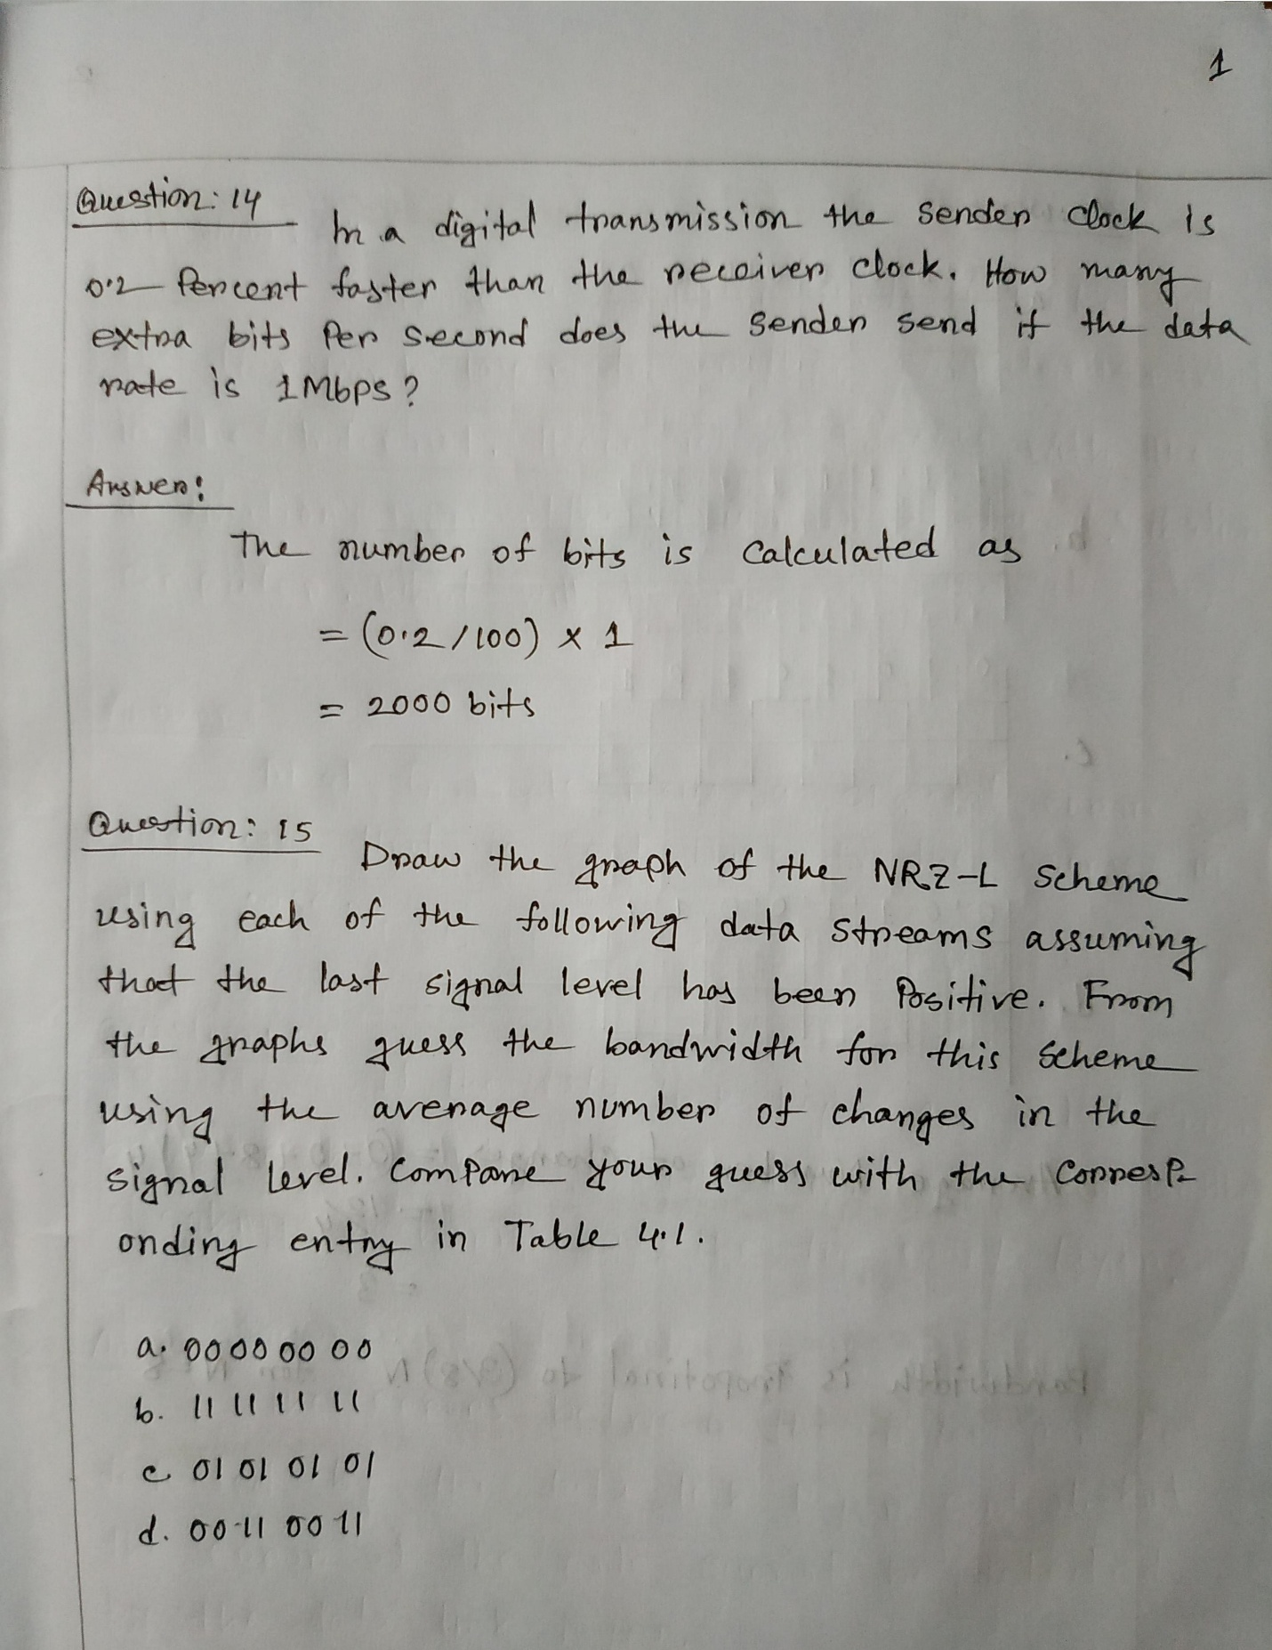

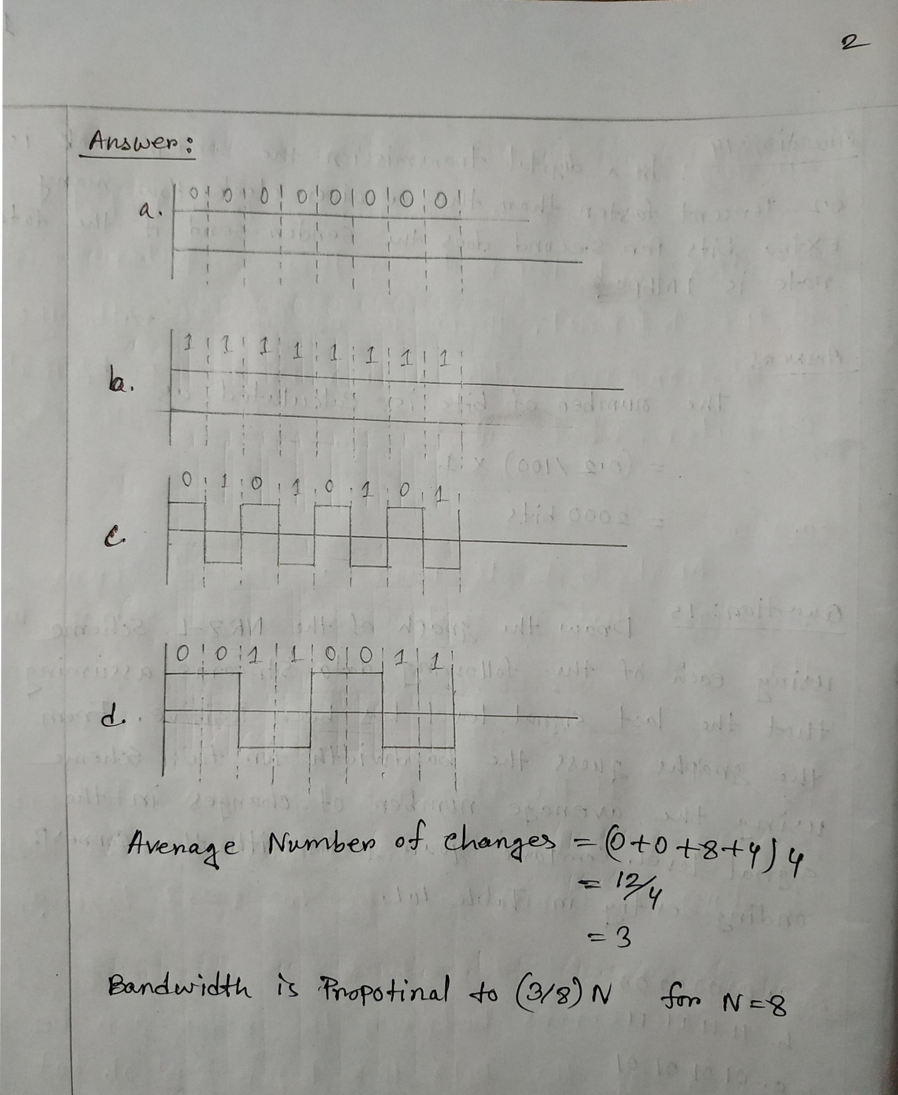

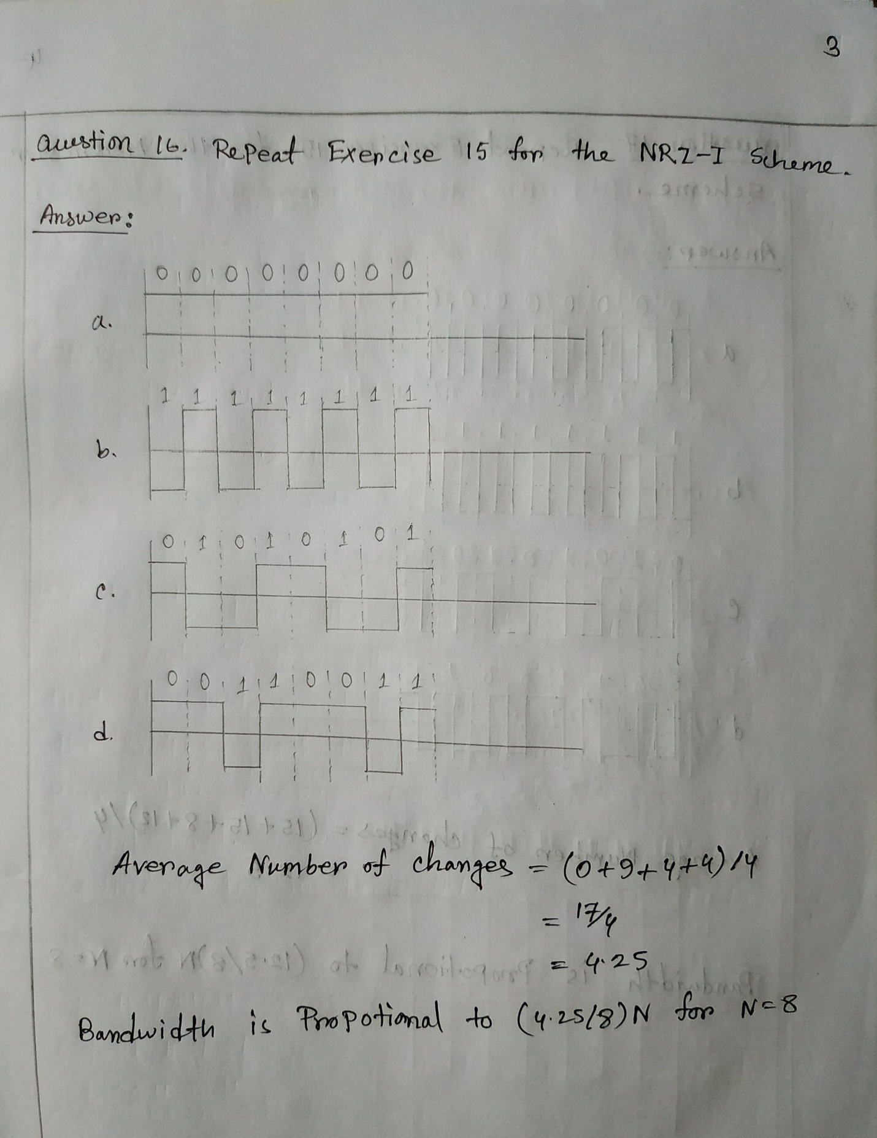

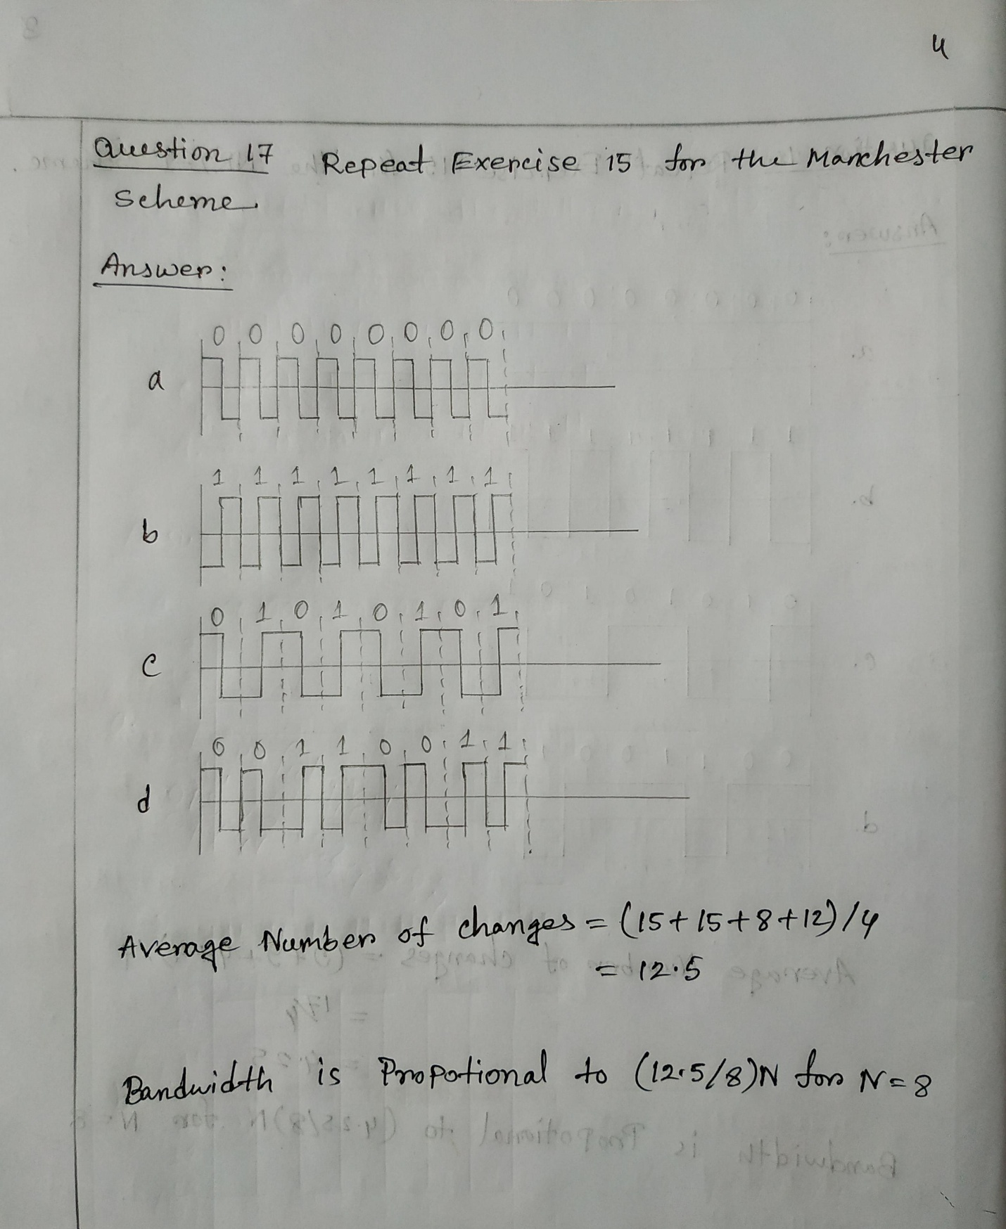

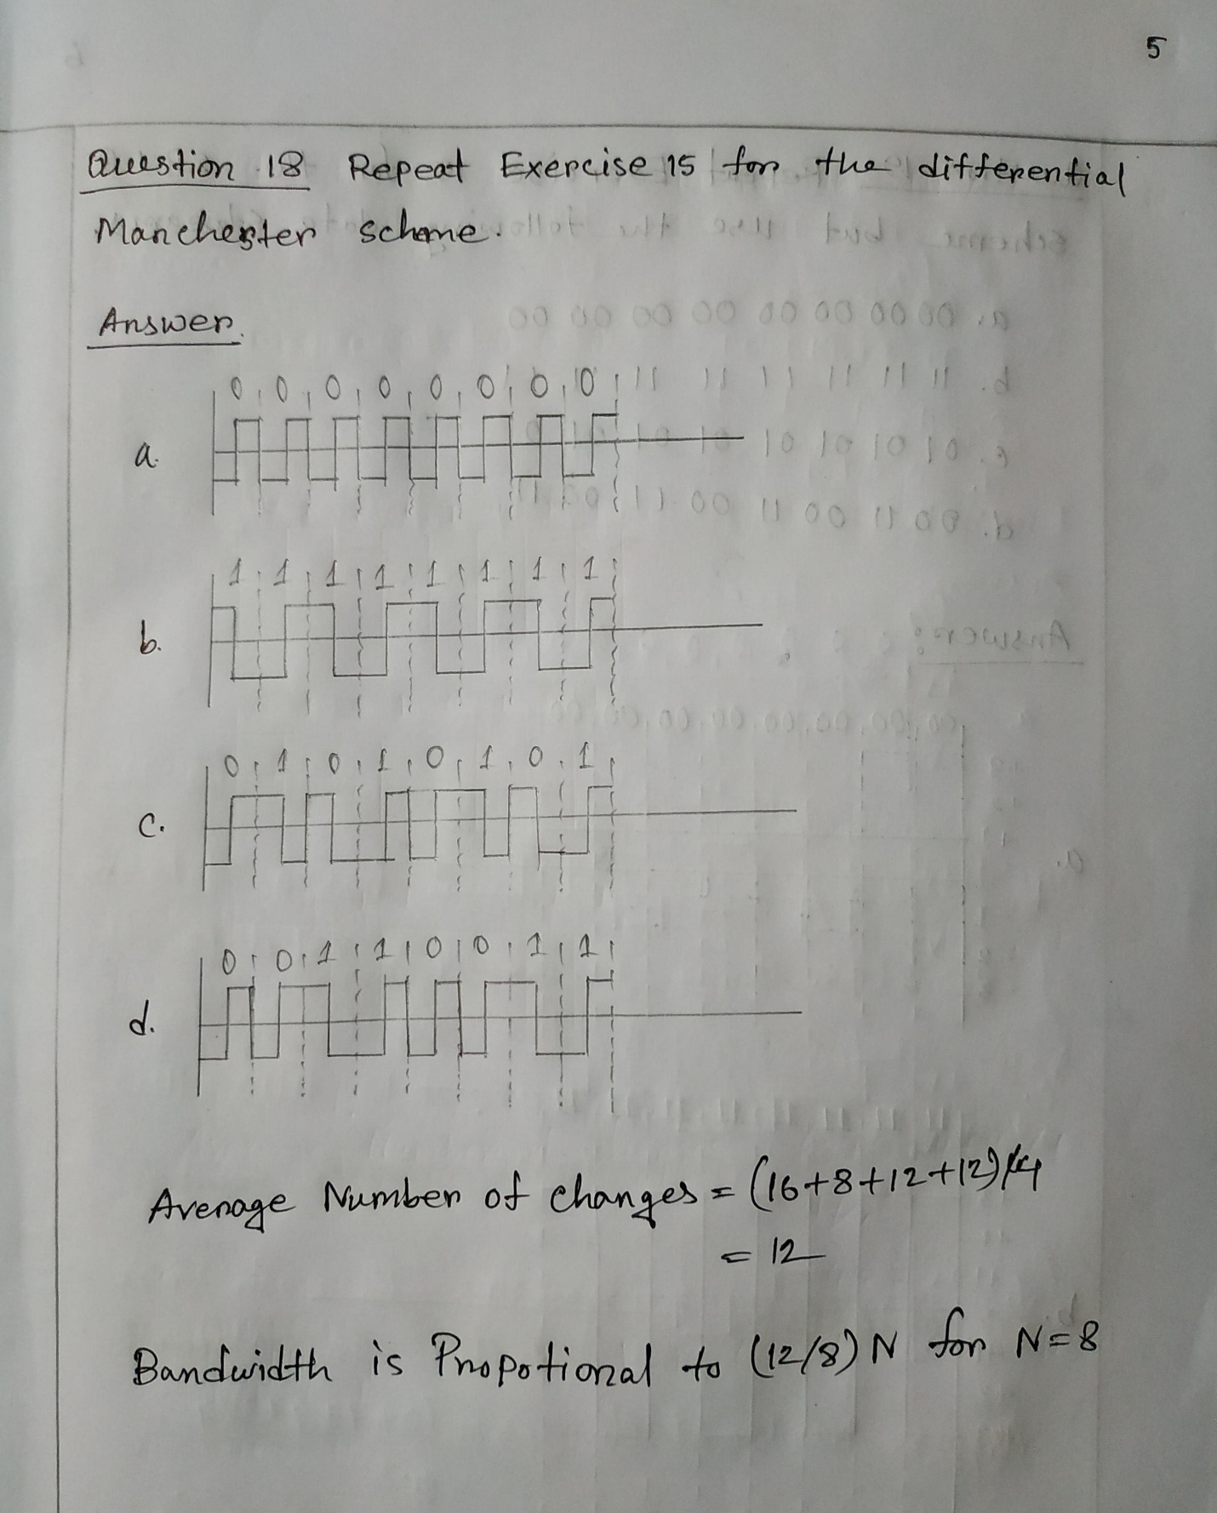

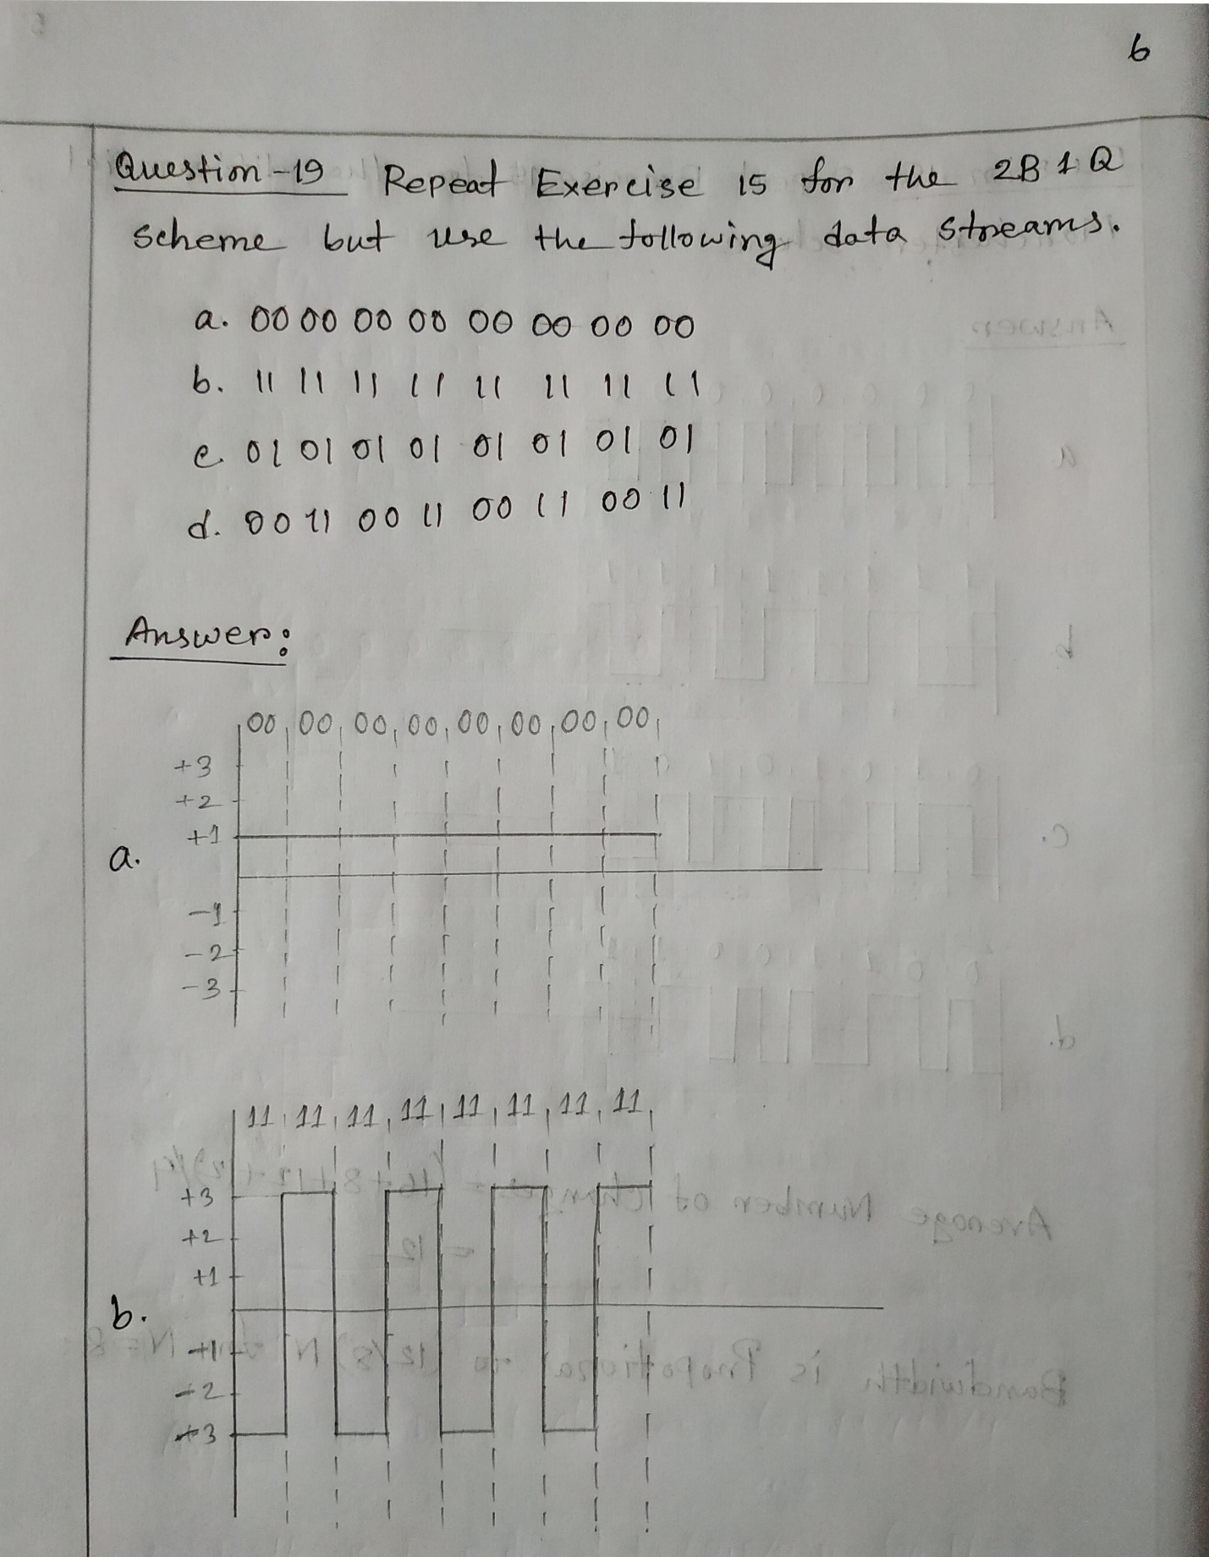

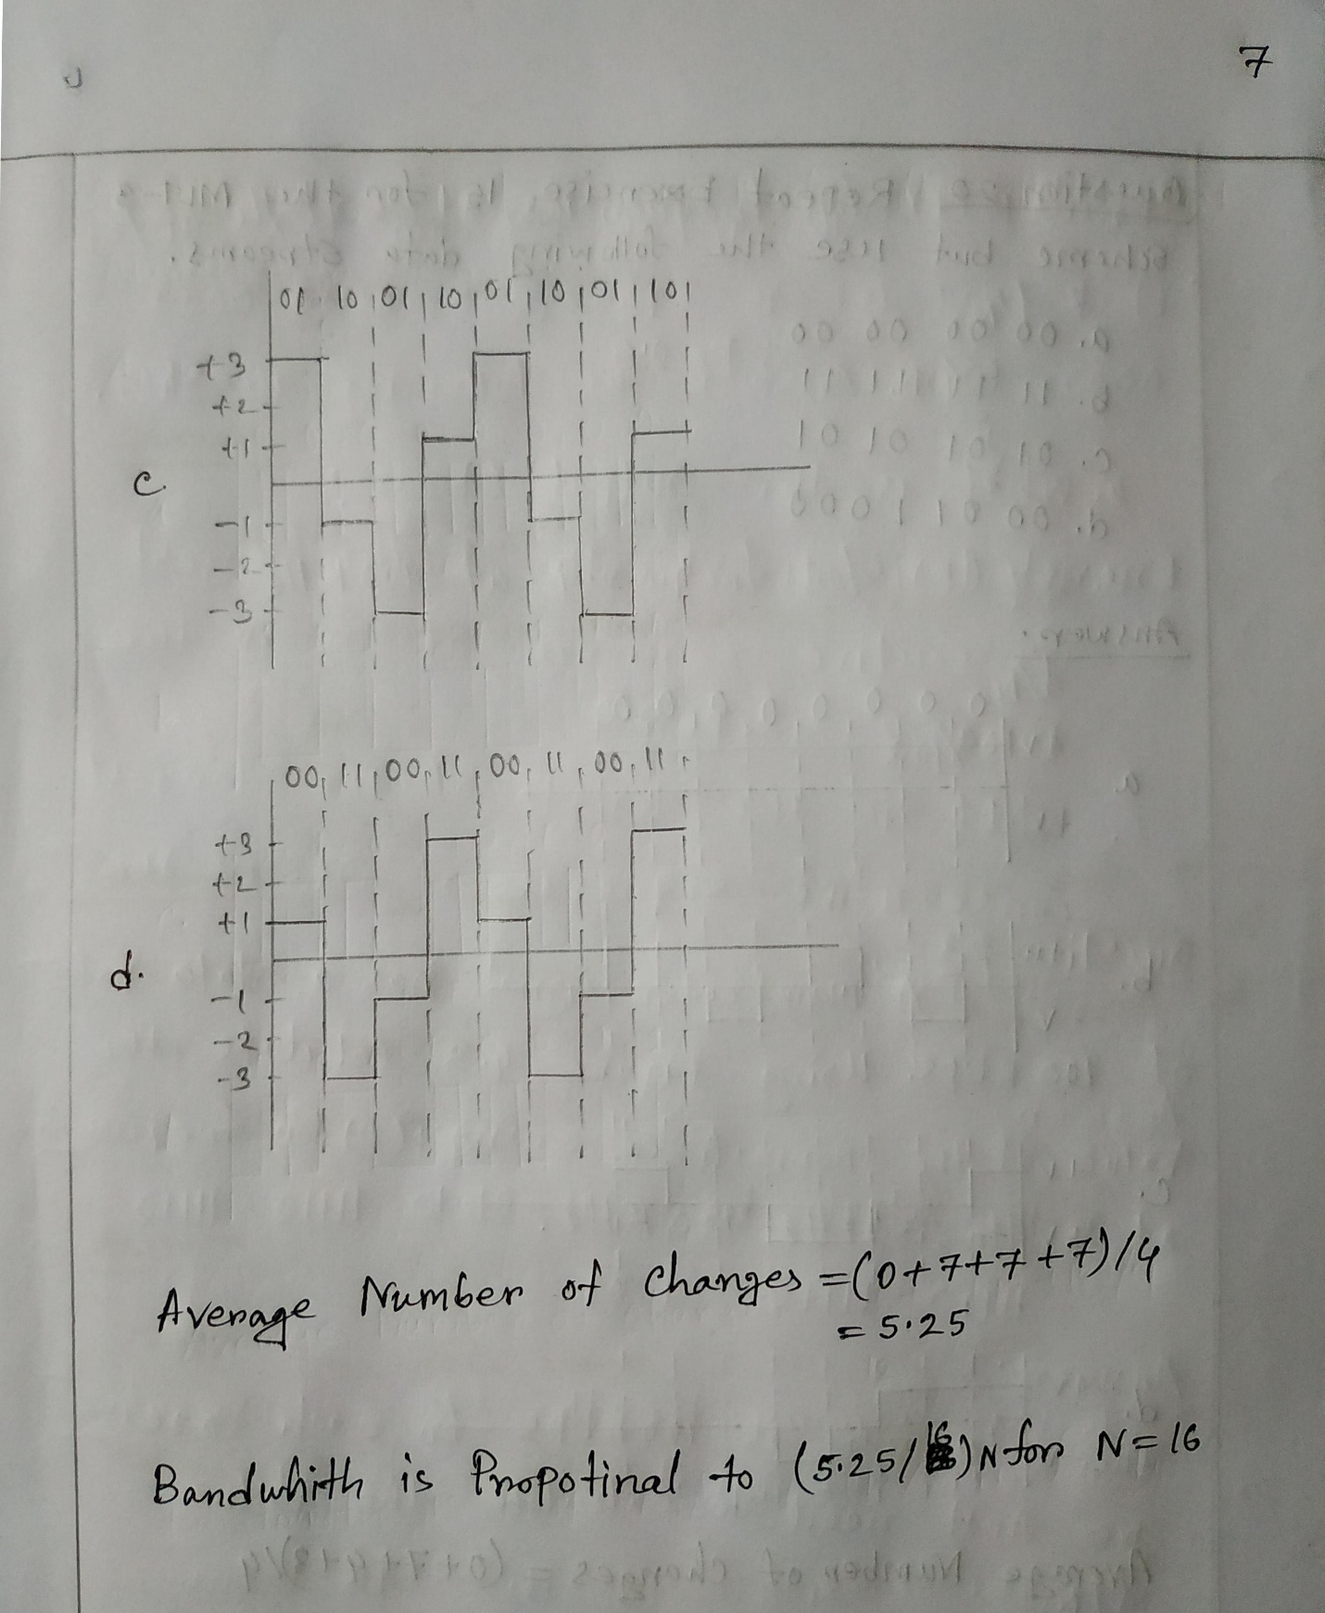

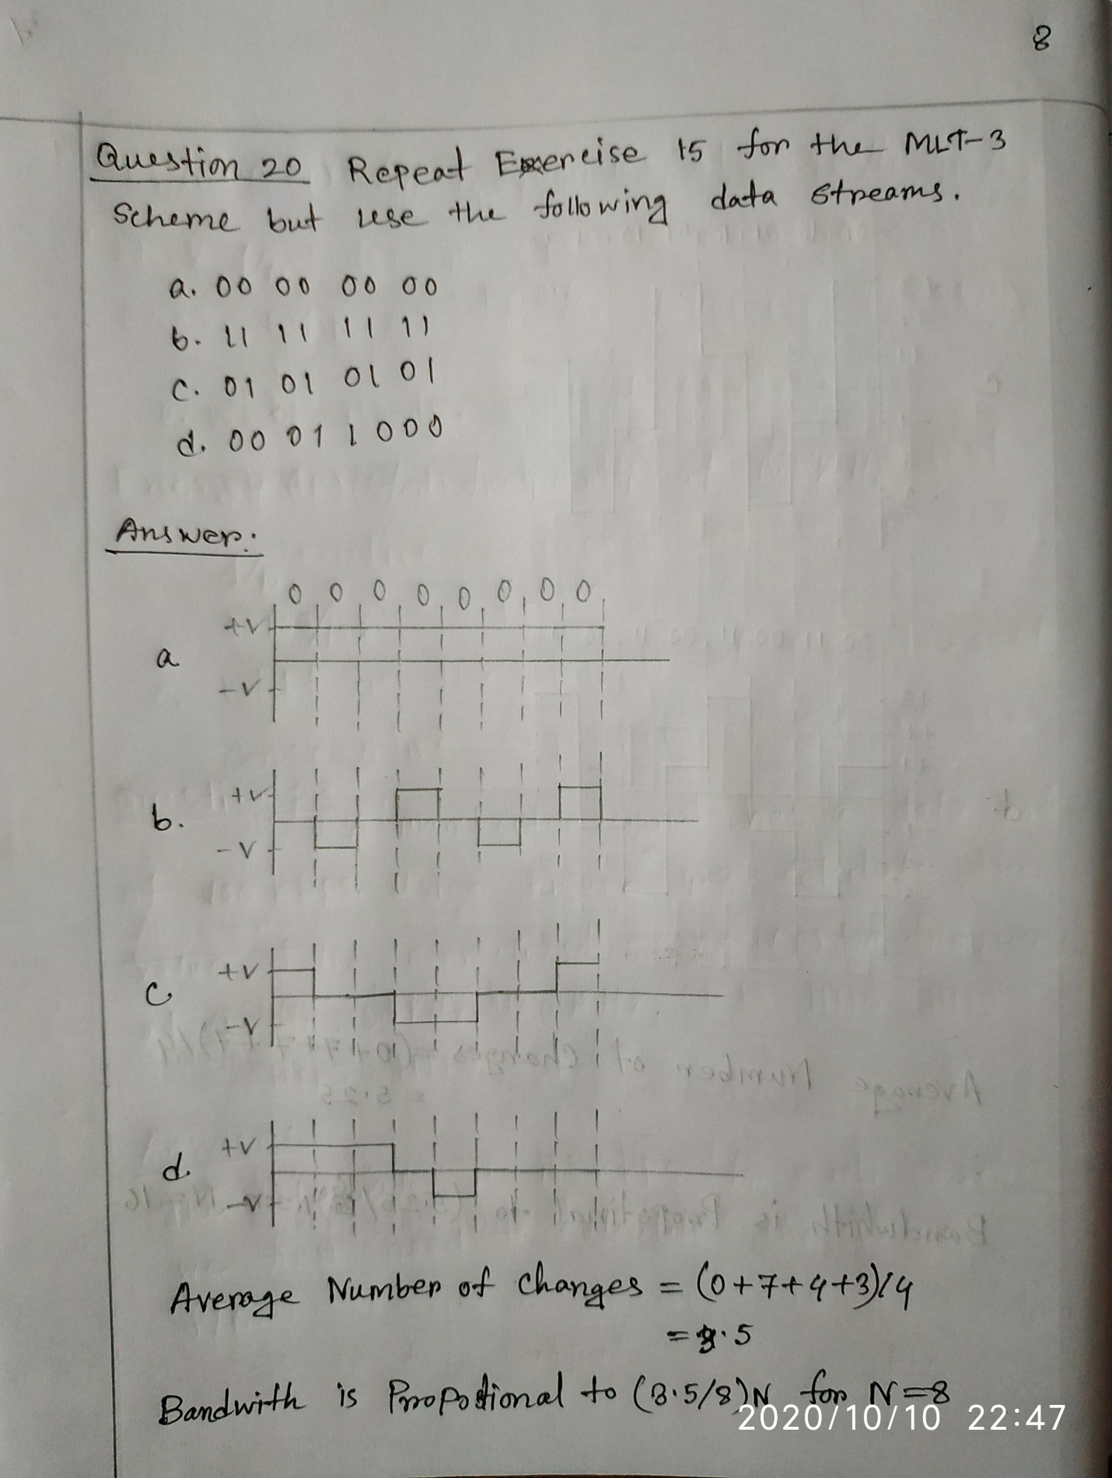

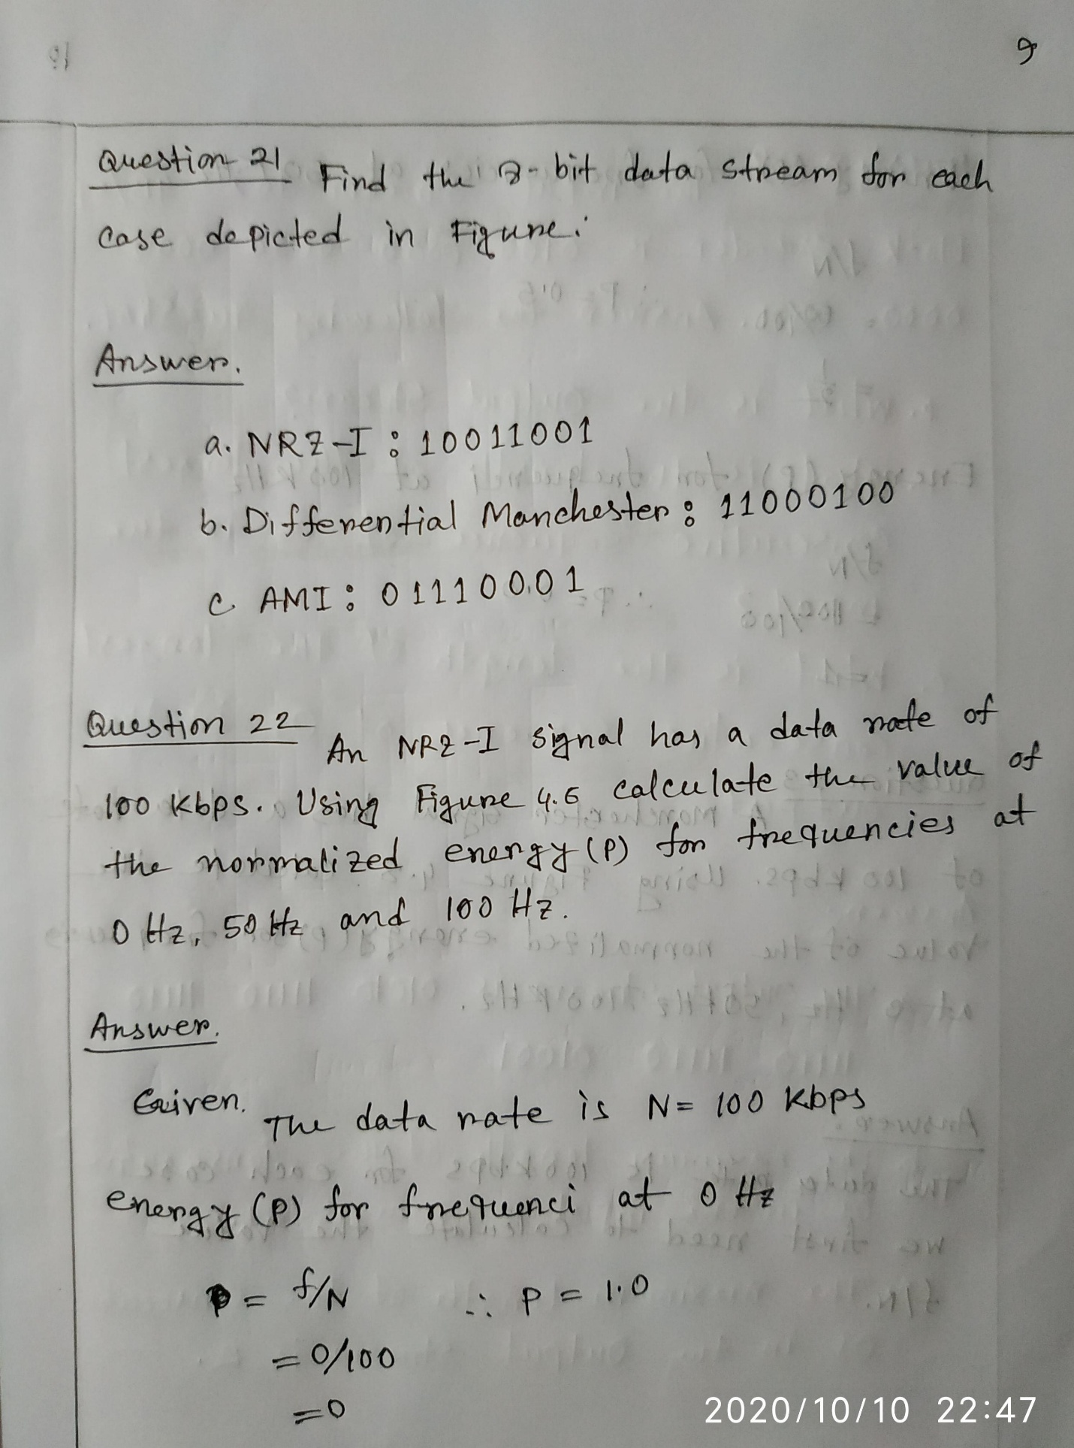

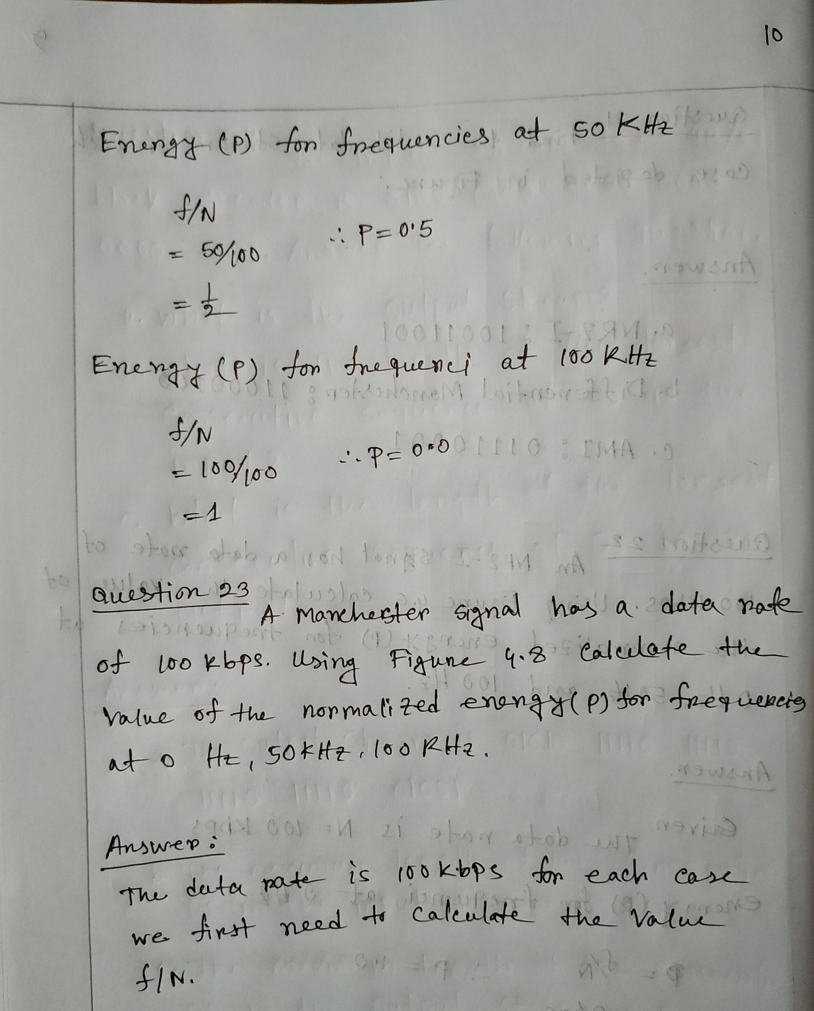

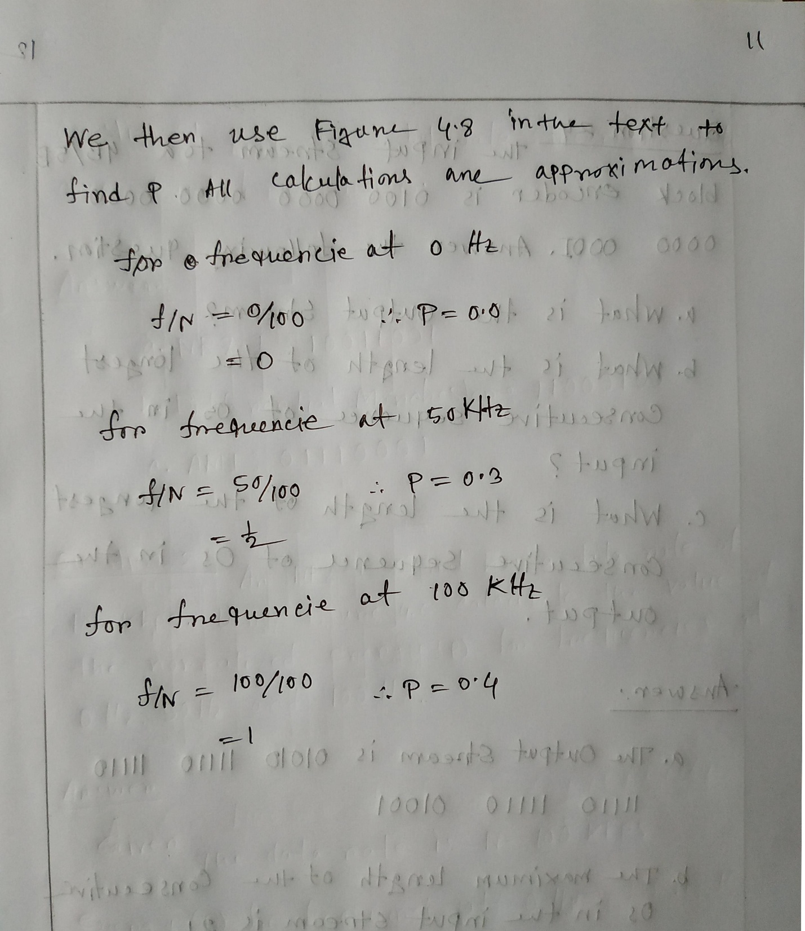

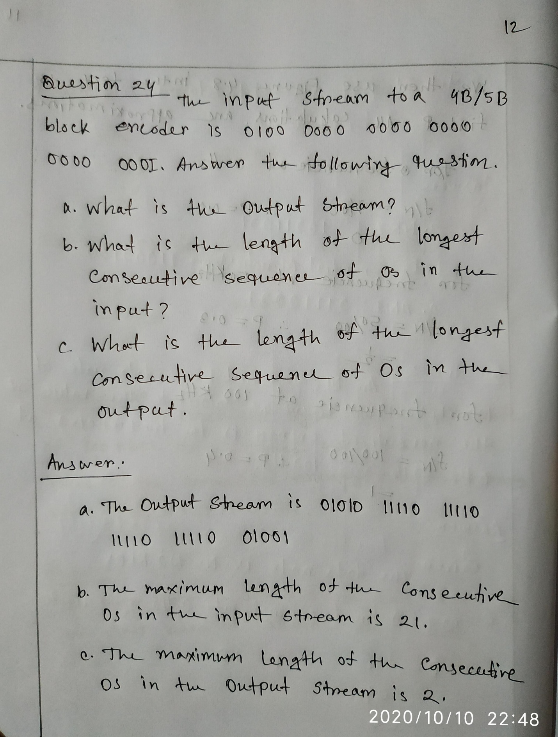

**The End**